Image | 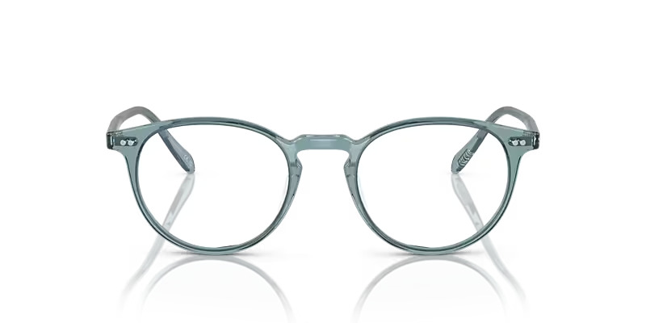
Brand | DIOR
Model Name | RILLAY.R
Price | RS 2000
PRODUCT DETAILS

